* Euclidean vs Manhattan distance |x2 - x1| + |y2 - y1|.
* 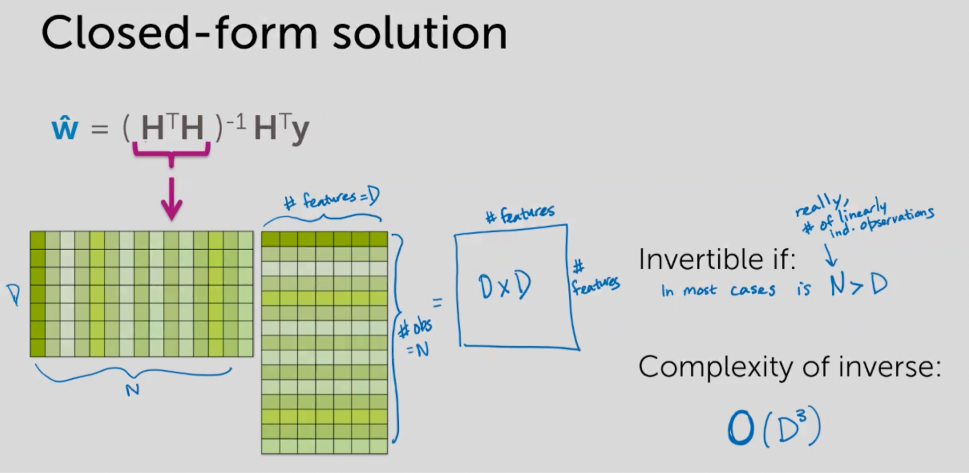 which is overcome in ridge
* Local linear regression defines weights for different features in KNN that is apart from distance, importance of feature is also considered.
* When to use gradient ascent and when to use gradient descent.
* Difference between scikit and statsapi and turicreate
* Different plots in data exploration
* ROC curve

**CLASSIFICATION:**

* For classification using 1 vs all: What if we have many classes? We will be training many models.
* Logit function maps (-infinity, +infinity) to (0.1) but what if I want (-10,15) to (0,1)
* *DONE: Instead of a maximum likelihood function, why can’t we train like regression, using RSS* ***?*** *Because score is something we predict and the actual output is only the predicted class.*
* Feature scaling in regression READ

To view all columns pd.set_option

### DATA IMPUTATION:

**Types of missing data:**

1. Missing at completely random: it's not related to data but some loss by one who is recording or loss in processing

2. Missing at random: particular group of data is missing

3. Missing not at random: amount missing data depends on data itself

**Methods for imputation**

1. Deleting the columns

2. Deleting the those rows

3. Creating new model to find those

4. Use mean median mode and also check for groups in between them.

5. To replace outliers, replace 95 percentile by 5 percentile continuous.

6. Categorical values replace by mode

7. Skewed continuous data by median

### PLOTS IN EDA

Heat map for missing data

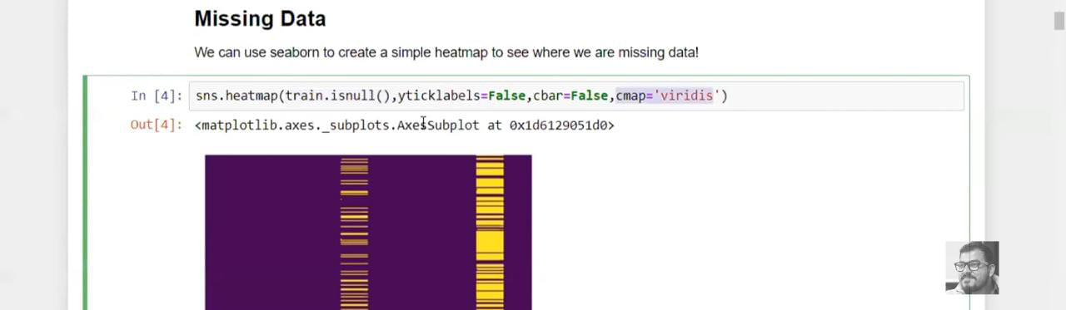

sns.heatmap(df.isnull(),yticklabels = False, cbar = False, cmap = ‘viridis’)

1. **Pair plot**

* Can plot only numerical not categorical values
* When customised, we use it as pairgrid and not pairplot. it is very helpful https://towardsdatascience.com/visualizing-data-with-pair-plots-in-python-f228cf529166
* Link for code: https://towardsdatascience.com/visualizing-data-with-pair-plots-in-python-f228cf529166

1. **Histograms and density plot**

* Histograms explain well when bin size is changed. It can tell if we can round of values.
* Density plots tell about distribution
* Histograms is for numeric variables to give frequency and value of variable

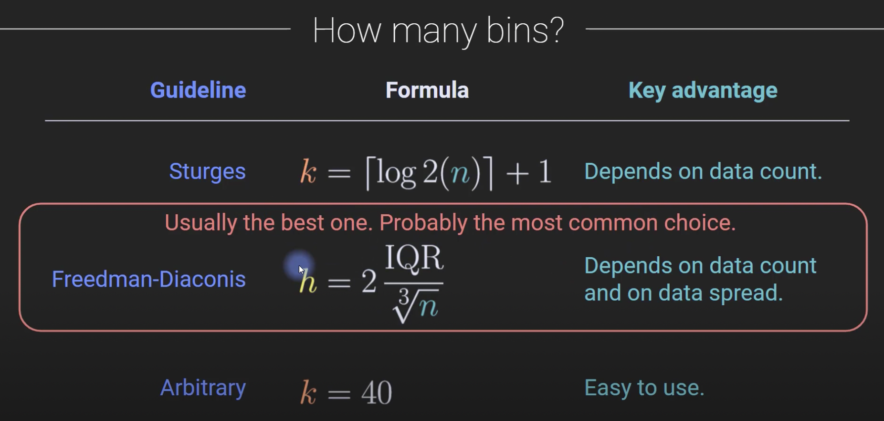

1. **Count plot**

Histogram for categories

1. **Bar chart, Swarm plot, strip plot**

Used for categorical vs continuous variable

1. **Box plot**

Used for percentile distribution and outliers

1. **Violin plot:**

Like box but also tells about density

**Implot adds regression line to scatter plot**

https://sahanidharmendra19.medium.com/common-eda-plots-in-datascience-projects-29e47a03a91d

### ENCODING OF CATEGORICAL VARIABLES:

Type of variable depends on the data

* **Ordinal Data:** The categories have an inherent order
* **Nominal Data**: The categories do not have an inherent order

**NOMINAL ENCODING:**

* One hot encoding
* One hot encoding with many categorical variables
* Mean encoding

**ORDINAL ENCODING:**

* Label encoding
* Target guided ordinal encoding

**TYPES OF ENCODING:**

1. **Label encoding or ordinal encoding:** Here, order of categories are considered. The categories are mapped to values and magnitude of values depend on order of categories.
2. **One hot encoding:** Here, the order of values is not considered. The categories are encoded in the binary form based on whether that category on present.
3. **Dummy encoding:** Dummy encoding is like one hot encoding, only N-1 variables are considered and one variable is encoded as 000
4. **Effect encoding:** Like dummy but instead of 000, -1 -1 -1 are encoded
5. **Hash encoder:**
6. **Binary encoding:** Like label encoder but in binary form.
7. **Base N encoding:**  Similar to binary but considers different base.
8. **Target encoding:** For each category, it encodes its value with the mean of target variable or posterior probability or a rank based on this mean for ordinal and take mean for nominal. It may lead to overfitting. To avoid this, we can introduce some gaussian noise in the target. Leave one out encoding can also be used.
9. **Normalization** is good to use when you know that the distribution of your data does not follow a Gaussian distribution. This can be useful in algorithms that do not assume any distribution of the data like K-Nearest Neighbors and Neural Networks.
10. **Standardization,** on the other hand, can be helpful in cases where the data follows a Gaussian distribution. However, this does not have to be necessarily true. Also, unlike normalization, standardization does not have a bounding range. So, even if you have outliers in your data, they will not be affected by standardization
11. **Weight of evidence:** Similar to target but instead of probability, we here consider the ln( % of occurrence / % of not occurence)

### PERFORMANCE METRICS FOR REGRESSION

**R2** - It tells us how a good model fits as compared to considering mean value. Adjusted R2 is used. It is like Sum of squared errors / mean

**MAE:** Does not detect outlier, scale dependent thus 2 models with different units cannot be compared.

**MSE** - sensitive to outliers, good to identify outliers but is scale dependent and value is not in same units of y so difficult to interpret.

**RMSE -** Like MSE, useful for comparing outliers but further value is in the same units as y, hence easier to interpret. But scale dependent thus 2 models - one with sales very high and sales very low cannot be compared

**MAPE** - In % form. Not sensitive to outliers, hence difficult in identifying outliers but models can be compared irrespective of y. Affected by magnitude of y i.e. y = 2, yhat = 1 has 100% error and y = 1000, yhat = 800 has 20% error.

**WAPE:** In % form and insensitive to magnitude but still cannot outliers.

**WWAPE:** Like Wape but weights the observations

### PERFORMANCE METRICS FOR CLASSIFICATION:

* **Accuracy** is considered for balanced dataset
* **Precision:** Exactness
* **Recall:** Completeness
* **F1 score.**
* **TPR:** True positive rate or sensitivity is probability that positive predicted score will be positive TP / (TP + FN)
* **FPR:** false positive rate or specificity is probability that actual negative will test negative i.e. TN/( TN + FP)
* **AUC:** Area under the curve TPR v/s FPR
  + ROC curve is TPR vs FPR for different thresholds, When TP is important than TN instead of FPR Precision can be used
  + For threshold = 1, the point is at the origin & for threshold 0, right most point is considered
  + Roc_score = 0.5 indicates a random predictor thus for a classifier score should be > 0.5

### Ensemble methods:

1. **Bagging or bootstrap aggregating**: Bagging divides the dataset into subset i.e. bootstrapping or row sampling with replacement and then trains models on these datasets and aggregates the final result. Random forest is different in a way that it not only uses a subset of models but also uses different features for training the model i.e. along with row sampling with replacement it also performs column based sampling with replacement.

A single decision tree on increasing the depth leads to low bias and high variance, but bagging helps in reducing the variance as well.

1. **Boosting**: it uses the previously trained model to train the current model. Generally, records for which model performed incorrectly is used to train the next model. E.g. for Adaboost, It weighs the incorrect measurements and focuses more on it.. For the final model, weighted average is considered
2. **Stacking:** combines multiple models e.g. NN, Random forest etc.

### Random forest:

Decision trees are inaccurate but simple.

1. Create a bootstrapped sample i.e. consider a sample of the data randomly, but data can be repeated.
2. Build a tree using random features at each level i.e. consider random features at each level and select the best one.
3. Bootstrapping the data + using aggregate to select the output is Bagging.
4. Typically, ⅓ of the dataset is not included in the bootstrap data set because of repetition and that data is called out of bag dataset
5. At each step number of random features selected is decided from iterations of which give the most accurate results.

To handle the missing data, randome forest initially gueses the value by median or mode. Then creates the tree using the data and the proximity matrix. The data in same leaf node denotes similarity.

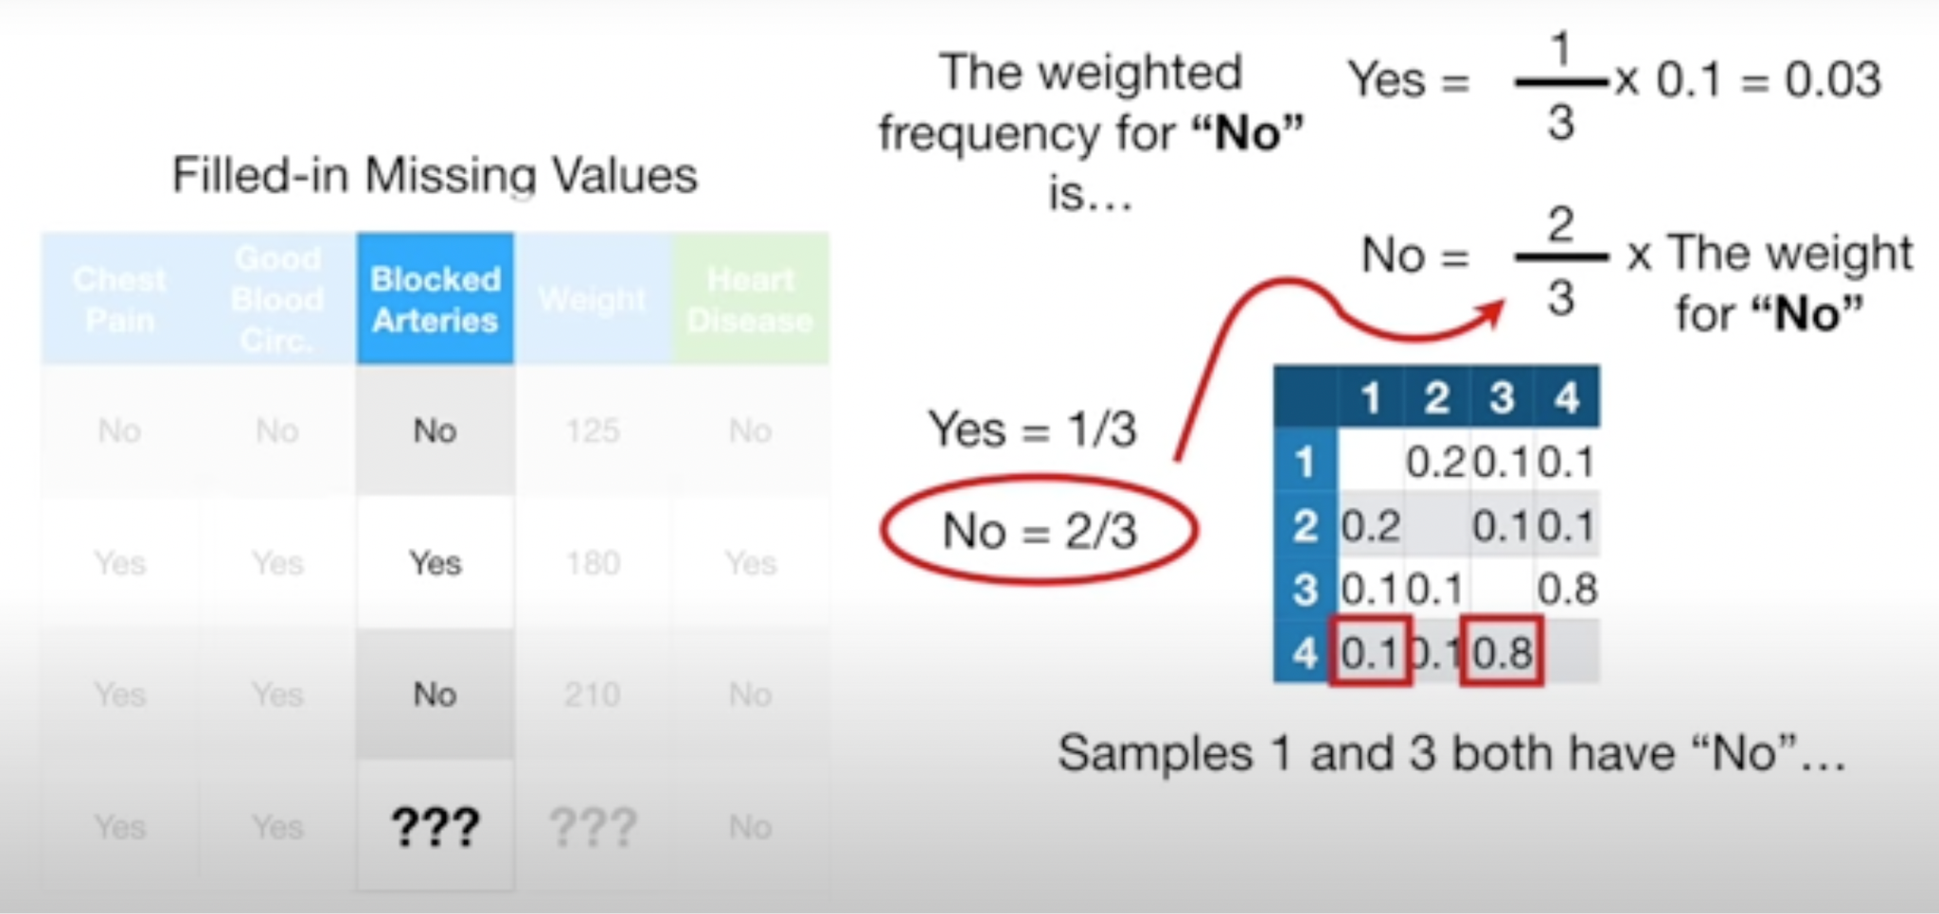 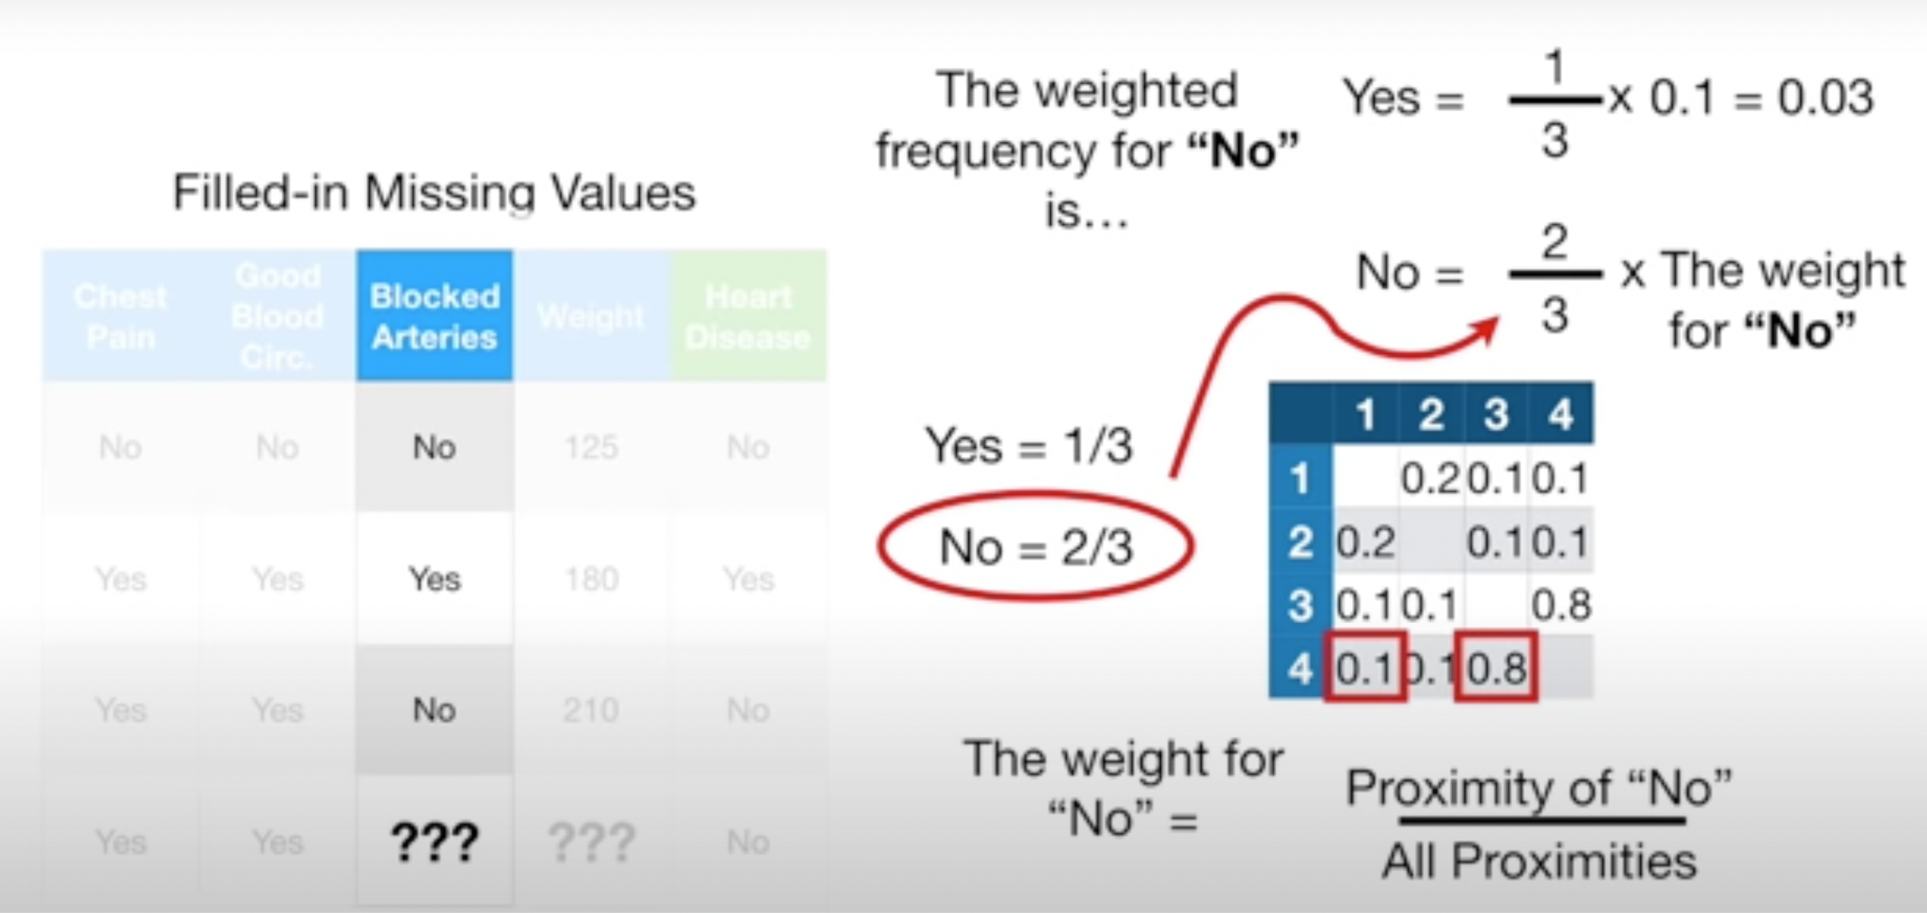

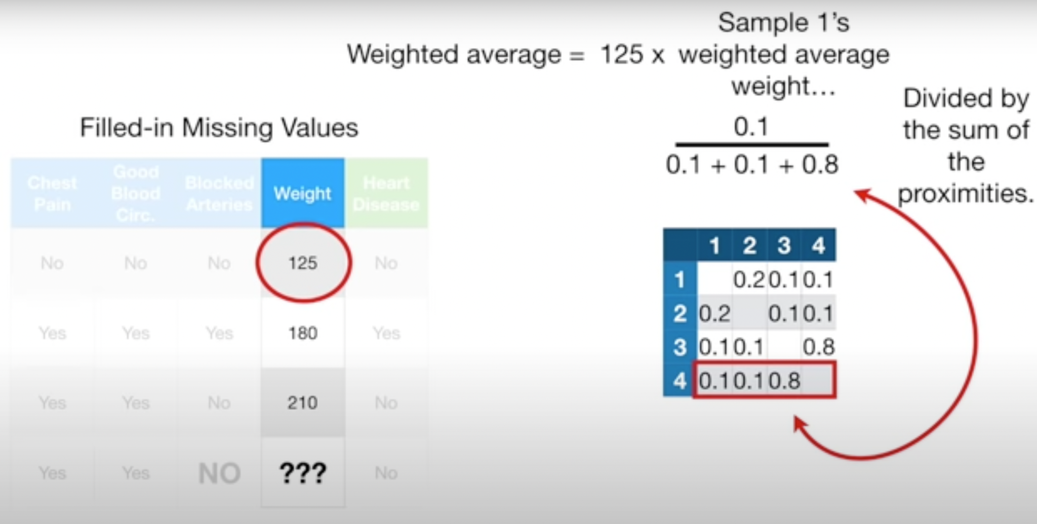 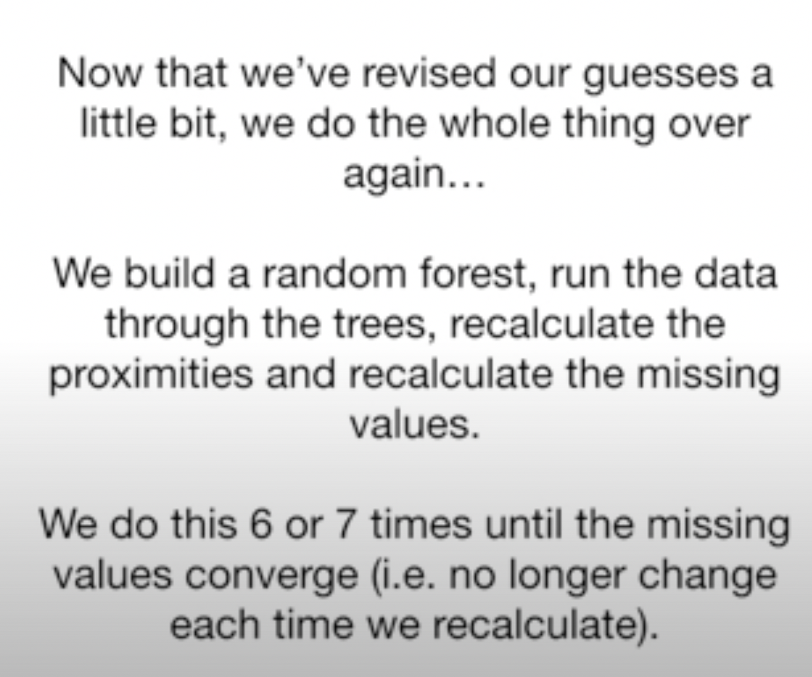

**1 - proximity matrix = Distance matrix**

### Adaboost:

Ada boost makes a forest of stumps.

1. Assign weights as 1/n
2. Stumps with every feature are created and stumps with minimum **entropy or ginny coefficient** are selected.
3. Data is passed and error, performance is calculated. ***Performance = 0.5*ln(1-TE/TE).***
4. Weights are updated. For in correct, ***new_wt = old_wt * e^(performance)*** For correct, ***new_wt = old_wt*e^(-performance)***
5. Weights are normalised.
6. Create a new dataset for new stumps based on buckets of weights. Because of updated weights, new data created has max data points which were incorrect.
7. Process is repeated.

### XGboost:

1. Using all the features and different categories of those features, we create decision stumps and calculate information gain.

**Information gain** = sum( similarity weight of leaves) - similarity weight of node.

**Similarity weight** =

[sum for all data points( Residual.square)] **/ [**sum for all data points (prob*(1-prob)) + regularisation **]**

1. Then we extend this stump to the tree using the same process. Then we calculate the updated probability.
2. Further, we recreate these trees.

### LIGHT GBM:

[**https://towardsdatascience.com/lightgbm-vs-xgboost-which-algorithm-win-the-race-1ff7dd4917d**](https://towardsdatascience.com/lightgbm-vs-xgboost-which-algorithm-win-the-race-1ff7dd4917d)

1. 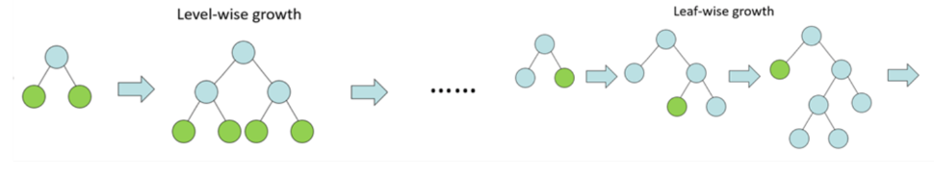
2. Buckets continuos variables using histogram based method, leading to lower memory usage, faster speed.
3. Because of leaf wise growth, better learning
4. Uses GOSS i.e. Gradient based one sided sampling to determine the split than XGB which uses histogram based algo.

### FEATURE SELECTION:

Impurity-based feature importances and permutation feature importance are two different approaches to determine the importance of features in machine learning models:

1. Impurity-Based Feature Importances: Impurity-based feature importances are commonly used in tree-based algorithms like Decision Trees and Random Forests. These importances are calculated based on the decrease in impurity (e.g., Gini impurity or entropy) when splitting a node using a particular feature. The idea is that features that lead to the greatest reduction in impurity are considered more important. The feature importances are computed during the training process of the tree-based models and can be accessed directly from the trained model.
2. Permutation Feature Importance: Permutation feature importance is a method that can be applied to any type of supervised learning algorithm. It evaluates the importance of features by randomly permuting the values of a single feature and measuring the decrease in model performance. The idea is that if a feature is important, permuting its values will disrupt the relationship between the feature and the target variable, resulting in a significant drop in model performance. Permutation feature importance provides a measure of the feature's contribution to the model's predictive power.

The main difference between impurity-based feature importances and permutation feature importance lies in their calculation and the algorithms they are applicable to. Impurity-based feature importances are specific to tree-based models and are computed based on impurity reduction, while permutation feature importance is a general technique applicable to any supervised learning model and relies on random permutation of feature values.

Both methods can provide valuable insights into feature importance, but they may yield different rankings or importance scores depending on the characteristics of the data and the model used. It's often beneficial to consider multiple approaches and interpretations when assessing feature importance in a given context.

### Types of cross validation:

Three commonly used variations are as follows:

* **Train/Test Split**: Taken to one extreme, k may be set to 2 (not 1) such that a single [train/test split](https://machinelearningmastery.com/train-test-split-for-evaluating-machine-learning-algorithms/) is created to evaluate the model.
* **LOOCV**: Taken to another extreme, k may be set to the total number of observations in the dataset such that each observation is given a chance to be the held out of the dataset. This is called leave-one-out cross-validation, or [LOOCV](https://machinelearningmastery.com/loocv-for-evaluating-machine-learning-algorithms/) for short.
* **Stratified**: The splitting of data into folds may be governed by criteria such as ensuring that each fold has the same proportion of observations with a given categorical value, such as the class outcome value. This is called [stratified cross-validation](https://machinelearningmastery.com/cross-validation-for-imbalanced-classification/).
* **Repeated**: This is where the k-fold cross-validation procedure is [repeated n times](https://machinelearningmastery.com/repeated-k-fold-cross-validation-with-python/), where importantly, the data sample is shuffled prior to each repetition, which results in a different split of the sample.
* **Nested**: This is where k-fold cross-validation is performed within each fold of cross-validation, often to perform hyperparameter tuning during model evaluation. This is called [nested cross-validation](https://machinelearningmastery.com/nested-cross-validation-for-machine-learning-with-python/) or double cross-validation.

### Hyperparameter tuning:

**Code file:**

[**https://github.com/codebasics/py/blob/master/ML/15_gridsearch/15_grid_search.ipynb**](https://github.com/codebasics/py/blob/master/ML/15_gridsearch/15_grid_search.ipynb)

**Youtube video:**

[**https://www.youtube.com/watch?v=HdlDYng8g9s**](https://www.youtube.com/watch?v=HdlDYng8g9s)

**Using for loop**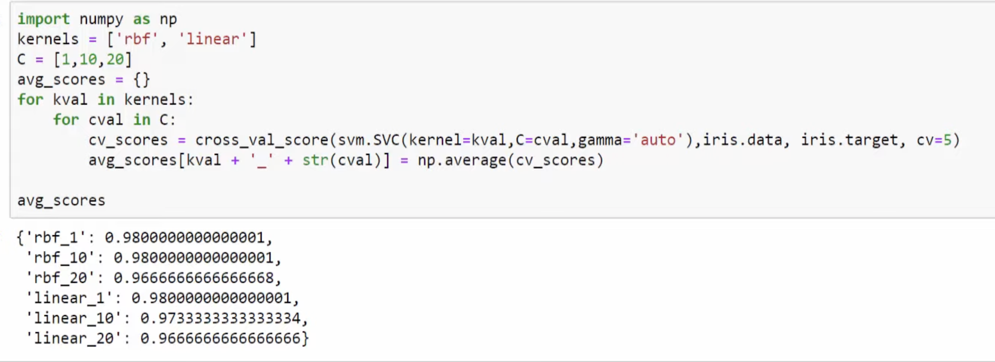

**Using Grid search: Something in single line:**

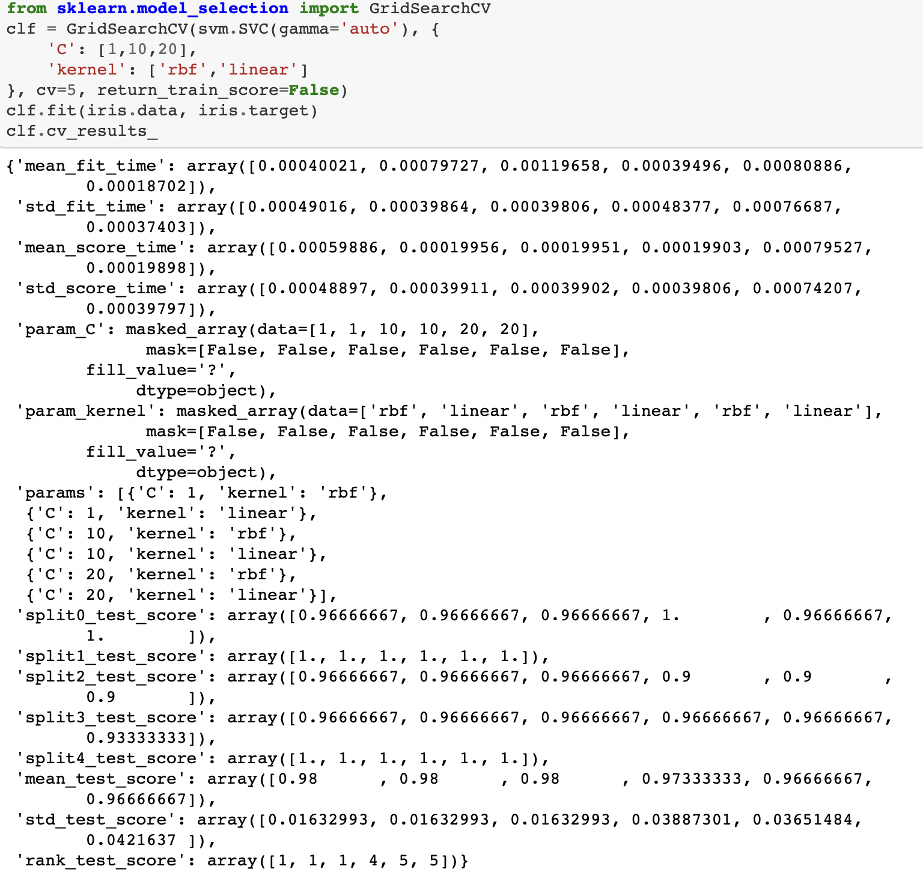

Clf.best_params: gives best parameters.

**Randomised search:**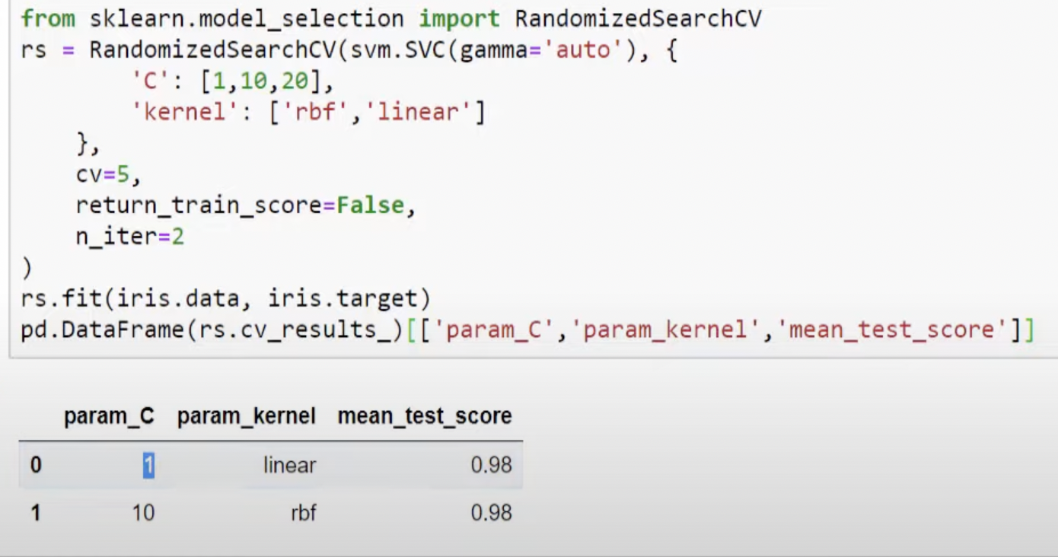

**Checking multiple models together**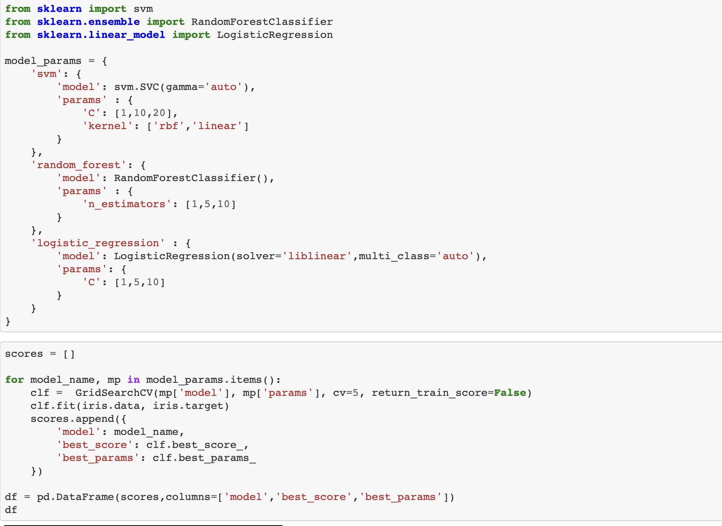

**Bayesian optimisation / Sequential model based optimisation:** The previous hyperparameters are used to choose a better hyperparameter in next step. It maps hyperparameter to the probability score using a surrogate model. This surrogate is easier to optimise than the original objective function.

Choice for the surrogate model are:

1. Gaussian process
2. Random forest
3. Tree Parzen estimators

Where as the criterion to select the hyperparameter is the **Expected improvement.**

**Surrogate function**: Probability model representation of the objective function.

<https://www.analyticsvidhya.com/blog/2021/05/bayesian-optimization-bayes_opt-or-hyperopt/>

### TYPES OF SCALAR:

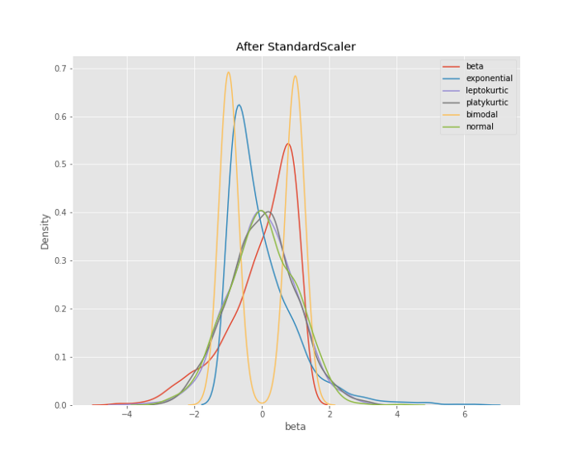

1. **Min Max Scalar:** For each value in the feature the min value is subtracted and divided by range. It preserves the shape of distribution, it doesn’t reduce the importance of outliers.
2. **Robust scalar:** It subtracts the median and divides by the interquartile range (75% - 25%). It reduces the effect of the outlier.
3. **Standard scalar:** Substracts mean and divides by standard deviation.
4. **Normalizer:** Normalizer in sklearn works **on rows and not on columns** the sum of values of feature is 1.

**Shapley values:** How much does a feature contributed to the difference of prediction and average prediction

Model agnostic: Applicable for any type of model

**Different types of test for correlation:**

1. ANOVA Test: <https://www.youtube.com/watch?v=jaD9haEi2B8> gives intuition

**TYPES OF CLASSIFICATION MODELS:**

**IMBALANCED DATA SET:**

### Normal distribution:

Bell shaped curved ideally symmetrical but practically skewed.

95% of data lie in mean +- 2 std

Wider the distribution, lesser the height & max probability.

Thus for determining bins, IQR is important

### Basics of Statistics:

#### **Null hypothesis**: No difference between things. To make a statement other than the null hypothesis, we need preliminary data, so the null hypothesis is used.

#### **p-value** :

* 1. Probability of accepting null hypothesis i.e. if null hypothesis was true, what is the probability of getting a particular outcome. If p value is high that means we have a high probability of getting this outcome, given that the null hypothesis is true so we accept the Null hypothesis.
  2. If it is very important that our inference is correct, alpha or significance value can be very small.
  3. Small p value doesn’t guarantee the impact i.e. is we say there is a difference, that difference can be very small like 1% or 40%.
  4. P-value : prob_of_our_event + prob_of_event_equally_extreme + prob_of_events_more_extreme
  5. 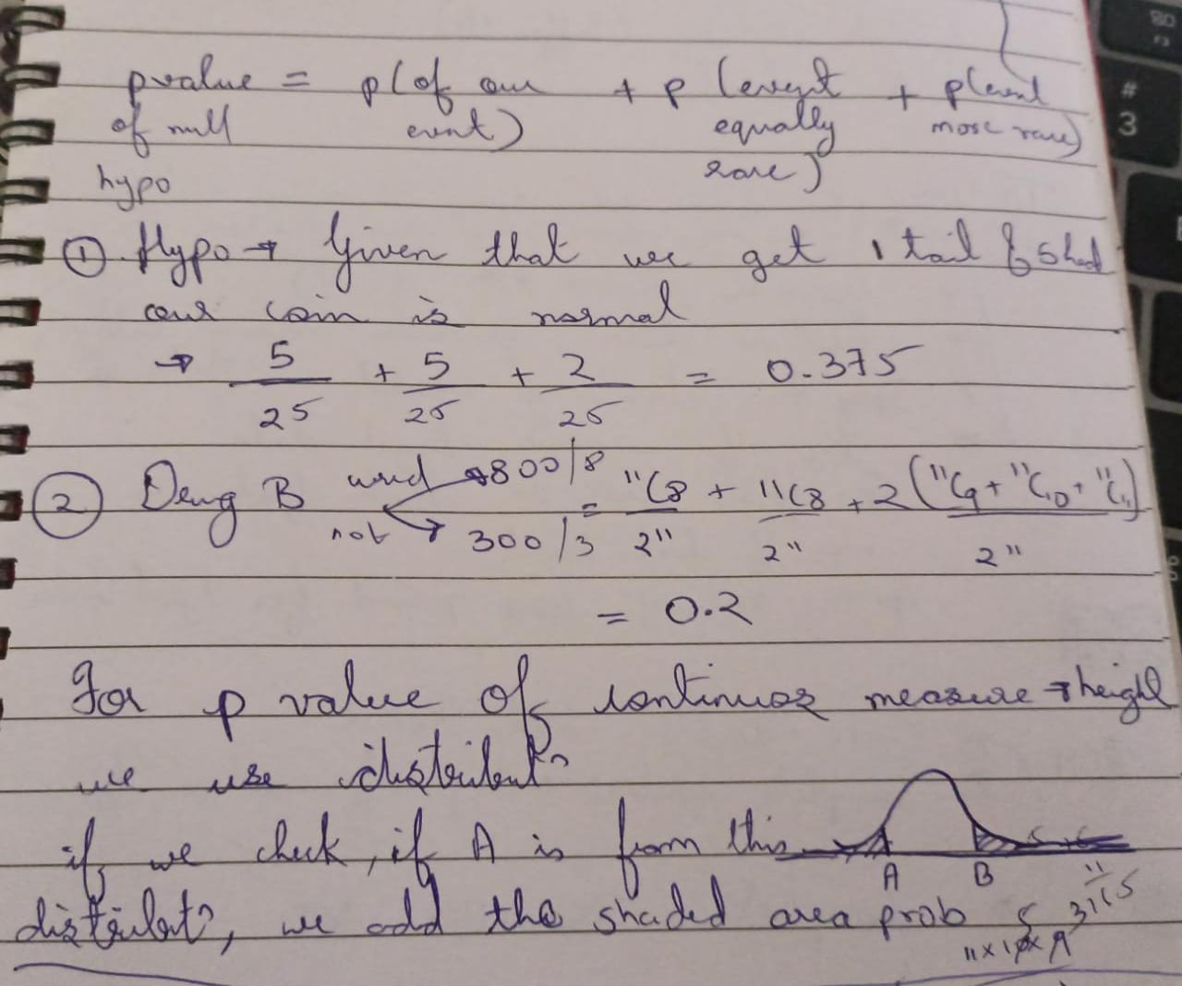
  6. In the above picture, eg 1 calculates p value of a hypothesis that if we get 1 tail and 5 heads on tossing a coin, our coin is no different.
  7. Eg 2 calculates p value for effectiveness of a drug given to 1100 people.
  8. Last part explains the formula for p value for continuous distribution.

#### Power analysis:

* 1. Power is the probability of correctly rejecting the null hypothesis or power is the probability of correctly getting a small p value. It is applicable only when we reject the null hypothesis
  2. We can increase power by increasing sample size & power analysis helps us determine the sample size required to have high probability of currently rejecting the null hypothesis
  3. Sample size by power analysis is to have confidence in the mean so that difference of 2 mean can be nearly the difference of population mean and we can be confident about the p value that we determine for the difference.
  4. Common value for power is 0.8

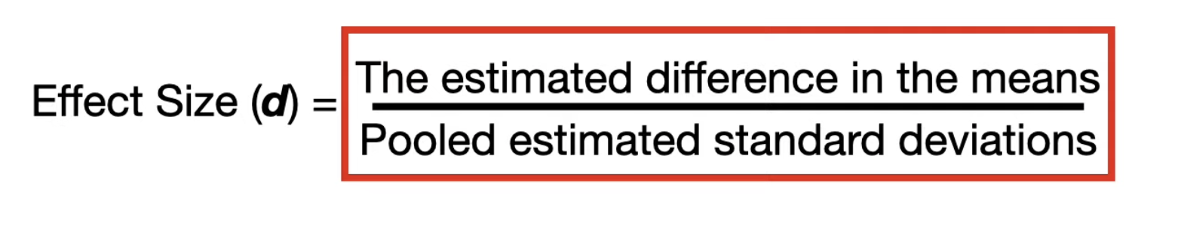

* 1. To determine the overlap, Effect size can be calculated.
  2. Then we can use the online calculator to determine sample size

#### T distribution and effect of sample size on approximating type of distribution:

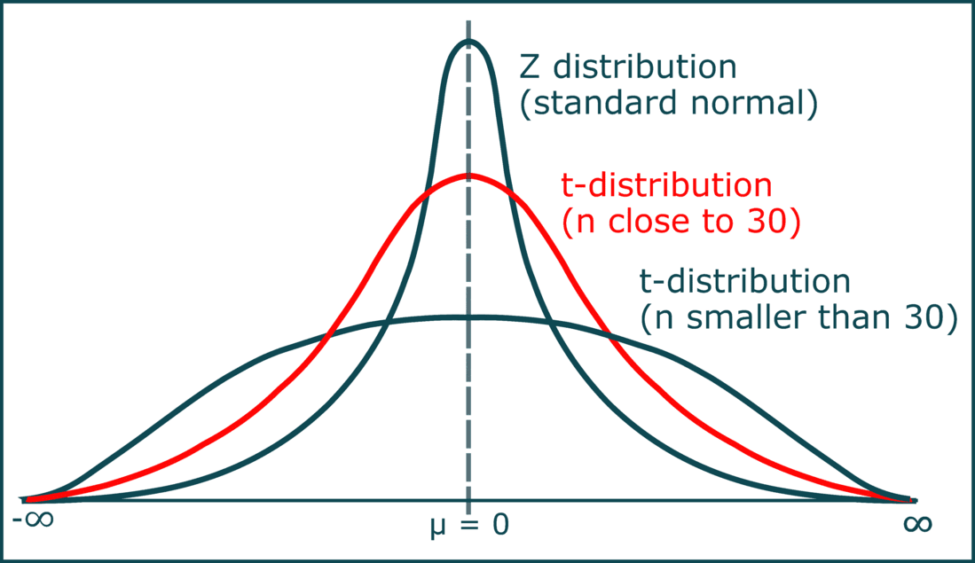

For sample size greater than 40 we approximate distribution to be a normal distribution else t distribution is considered.

### **Statistical test:**

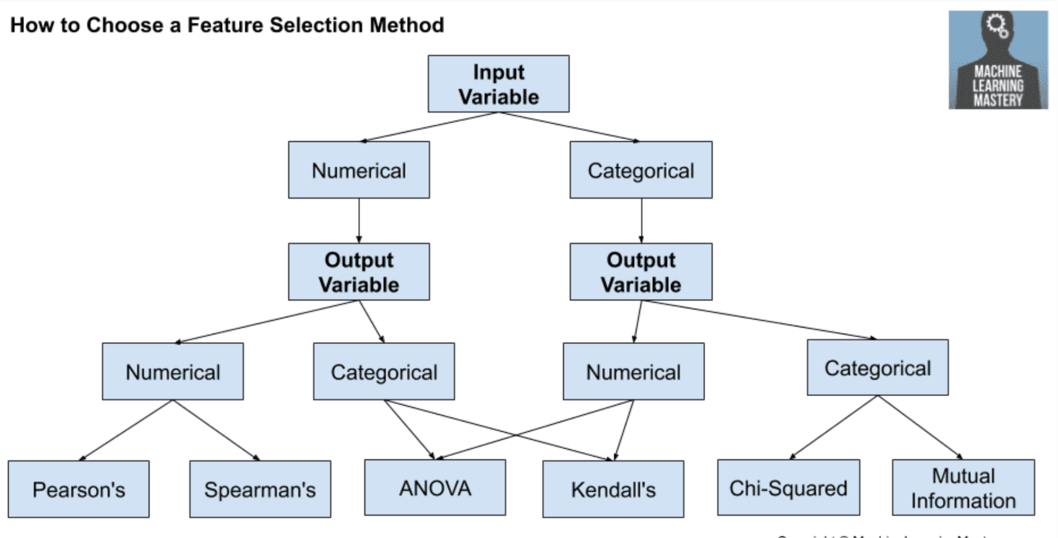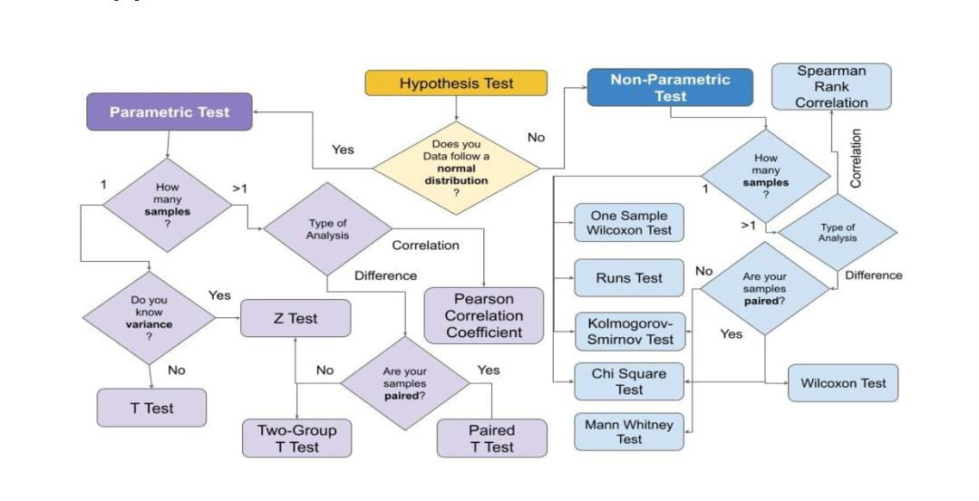

#### One and two sample:

When we want to compare two samples - correlations or difference, it is 2 sample.

When we want to compare single sample to a value, it is single sample.

#### Type 1 error:

When null hypo was true and we said it is false

#### Type 2 error:

when it was false and we accepted as true

#### Parametric and non Parametric tests:

When samples follow a normal distribution, we use parametric test.

When the underlying distribution is not known or not normal, we use non parametric test.

Parametric tests use mean as a central tendency where as non parametric test use median.

#### Comparison of correlation

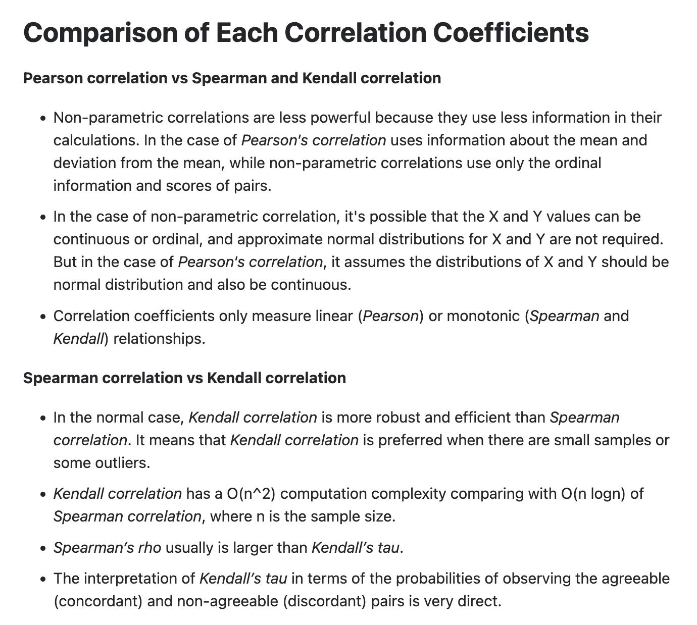

#### Chi squared test:

Chi square test is a non parametric test, used for:

1. If 2 categorical variables have relation in them (Does results i.e. pass or fail depend on gender)
2. If a categorical variable follows an expected distribution (No of ppl visiting restaurant doesn’t depend on the day of the week)

For 1 DOF is the total number of possible classes. Expected values are dividing total equally in all categories.

For 2, DOF is (n_rows-1)*(n_col-1). Expected value for a cell is Row_total * Column_total / Grand_total

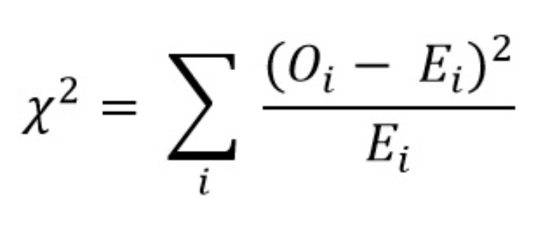 This the value of chi statistic, using which we calculate the critical probability and compare it to significance level

### REGEX

**Regex Pattern**: ^[A-Za-z][A-Za-z0-9_\.\-]*@leetcode(\?com)?\.com$

Let's break down the regex pattern step by step to clearly explain each part:

* **^**: Anchor the regex pattern to match from the start of the string.
* **[A-Za-z]**: Match any single uppercase or lowercase letter. The email prefix name must start with a letter.
* **[A-Za-z0-9_.-]**\*: Match any number of characters following the first letter in the email prefix name. It includes letters (upper or lower case), digits, underscore '_', period '.', and/or dash '-'.
* **@**: Match the literal '@' character, which separates the prefix name and the domain.
* **leetcode**: Match the literal 'leetcode', which is part of the email domain.
* **(?com)?**: Make the sequence ?com optional in the email domain. Allows the pattern to match both '@leetcode.com' and '@leetcode?com'.
* **.** : Match the literal '.' character, which separates the 'leetcode' part from the 'com' part of the domain.
* **com**: Match the literal 'com' at the end of the email domain.
* **$**: Anchor the regex pattern to match until the end of the string.

### **CODE OPTIMISATION**

1. **Query works faster than .loc** because of bytecode conversion
2. Instead of **df.loc[df.shape, :] = []** in a loop, **save all results in a 2D array** and create a dataframe and append
3. Select require columns before filtering.
4. Instead of **groupby.head(2)** we can use **nlargest** or nsmallest
5. Instead of **.isin(df[‘a’].unique())** we can use **.isin(set(df[‘a’])**
6. Sentence can be done by **.capitalize**
7. Use **list comprehension** rather than for loops
8. Use **range()** for sequence of numbers
9. **enumerate** can be used to create index, element pair.
10. **Map** applies a function to each element in an object, it can be used with lambda or any custom function also.
11. **Np,array** can be used for manipulations
    1. Np.array is alternative to lists
    2. No_array.dtypes gives dtypes of elements
    3. Np.array is homogeneous
    4. **Broadcasting** can be done only with numpy for eg squaring each element of a list can be done with list comprehension or loop but for array, squaring of elements in array A can be done by A**2
    5. Np.array has better indexing capabilities than lists for > 1D. Returning the 2nd item of the first row - ***array syntax*** is [0,1]; ***list syntax*** - [0][1]. Returning 1st column in the 2-d object, the ***array syntax*** - [:,0]. ***Lists don't support*** this use of list comprehension.
    6. **Boolean indexing:** With an array, we can create a boolean mask using a simple inequality. Indexing the array is enclosing this inequality in square brackets. **nums_np[nums_np > 0]** for selecting elements in array > 0, for list we need loops or comprehension
    7. S

### **IMPORTANT PYTHON FUNCTIONS**

1. print(‘’, **end = ‘’**)
2. string.**swapcase()**
3. datetime.**total_seconds(); %a, %A** weekday as Mon & Monday, **%b %B** month as Dec & December. See others [here](https://www.w3schools.com/python/python_datetime.asp)
4. **list( map(int, a) )** => where a is a list; Using map function
5. From collections import Counter; **Counter(a),** (we can get keys, values, most_common()

### **ENTROPY, INFORMATION GAIN and GINNY ENTROPY:**

**Entropy:**

log2(p) is log with base 2

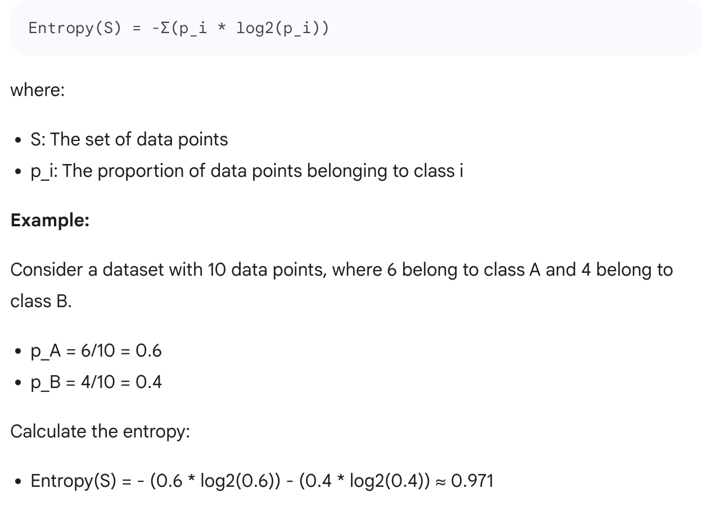

**Information gain:**

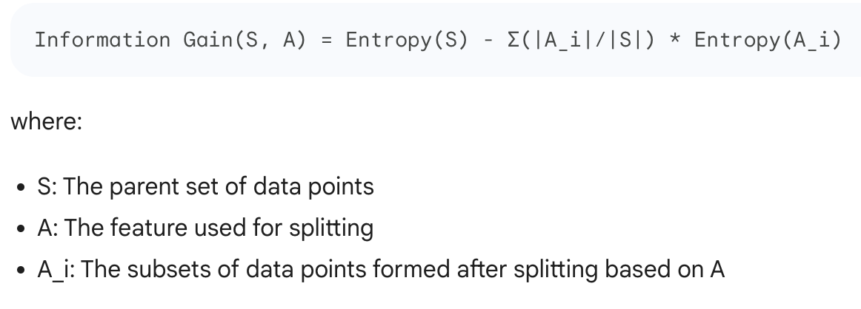

**Ginny entropy:**